A Complete Guide to the Math Object in JavaScript

Clem Onojeghuo on Unsplash
In JavaScript, Math is a built-in static object that allows you to perform mathematical operations on numbers.
Let's discuss some important methods that we can use in our regular life.

Math.max() and Math.min()
Math.max() is used to find the largest out of listed values, and Math.min() to find the smallest:
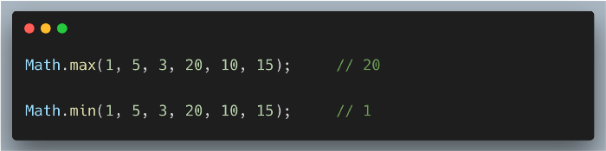
But what if we have an array of numbers and we would like to find the min and max value in it. If we send an array to Math.min or Math.max methods we will get NaN.
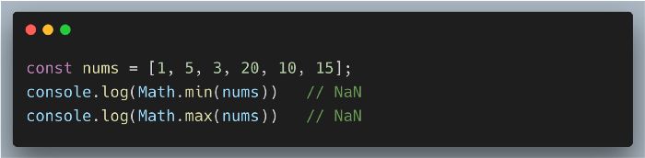
That is because Math.min or Math.max functions expect distinct variables and not an array. We can handle this in different ways
In ES5 we can handle it by using apply method
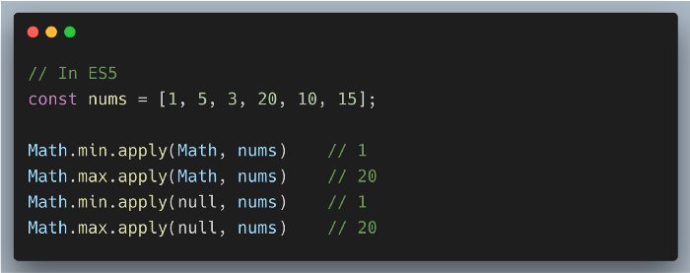
In ES6 we can handle it with spread … operator
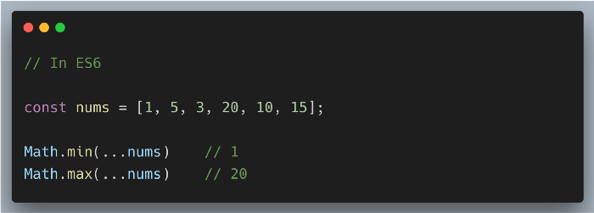
This operator causes the values in the array to be expanded, or “spread”, into the function’s arguments.
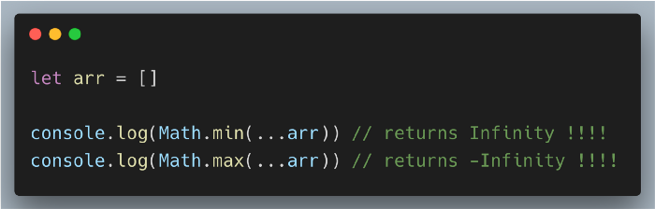

Math.round()
Math.round() is used to round a number to its nearest integer.
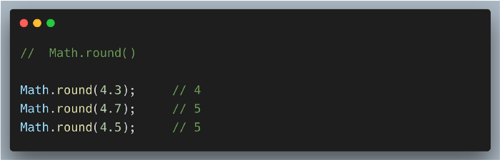

Math.ceil()
Math.ceil() is used to round a number up to the nearest integer:
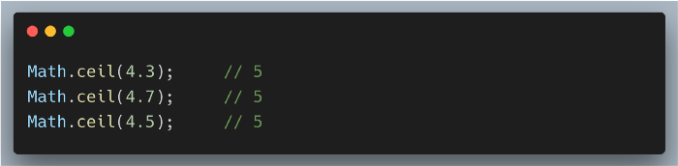

Math.floor()
Math.floor() is used to round a number down to the nearest integer:
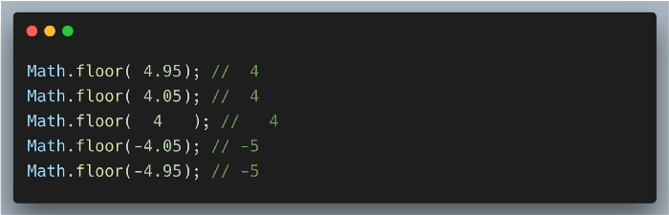

Math.abs()
Math.abs() method returns the absolute value of a number.
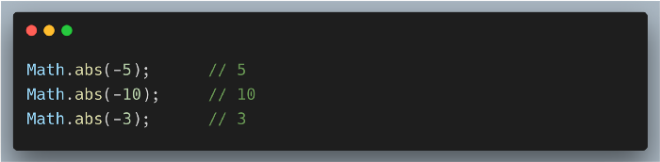
Let's see an example of subtraction used with the function below:
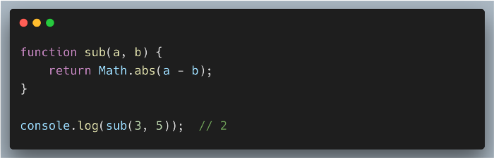

Math.random()
The Math.random() function returns a floating-point number that ranges between 0 to 1. It can be used to get a random number between two values.
To get a random integer between a min and max, the math.random() function can be used in the following way:
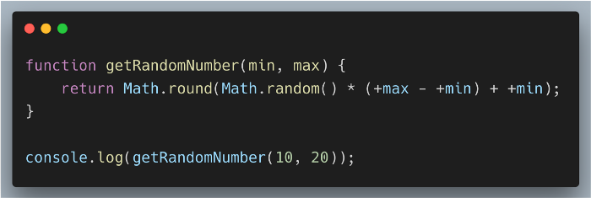
We can also generate a random color value by using Math.random()
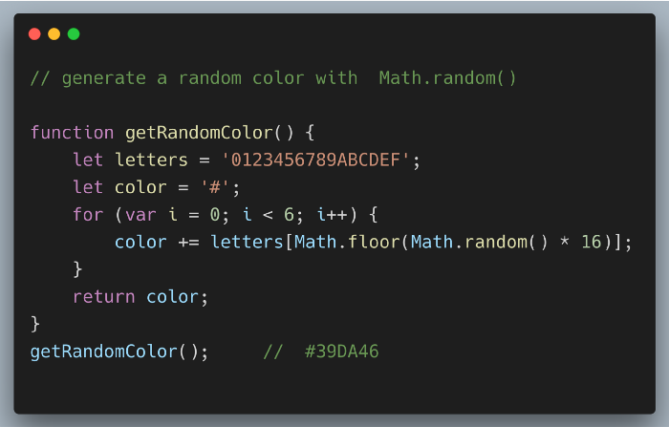
Math.random is a very useful method in real projects to generate random numbers, ids, and colors.
Unlike the other global objects, Math is not a constructor. All properties and methods of Math are static.
Thanks for reading :)
https://levelup.gitconnected.com/complete-guide-on-math-object-in-javascript-5c641254f288

